The Autobiography

Objectives:
Essential Questions:
- Who am I – how can I describe myself to other people?
- Why do people write biographies/autobiographies?
- What information should I include in writing a biography/autobiography?

- Students will develop a better understanding of their self-interests.
- Students will be able to write a five-paragraph autobiography.
- Students will be able to prepare and present a multimedia autobiographical presentation.
- Students will demonstrate effective listening and comprehension skills in response to their co-students

California English Language Content Standards:
Writing Strategies:
Organization and Focus
1.0 Writing Strategies
Students write clear, coherent, and focused essays. The writing exhibits students' awareness of the audience and purpose. Essays contain formal introductions, supporting evidence, and conclusions. Students progress through the stages of the writing process as needed.
1.2 Create multiple-paragraph expository compositions:
1. Engage the interest of the reader and state a clear purpose.
2. Develop the topic with supporting details and precise verbs, nouns, and adjectives to paint a visual image in the mind of the reader.
3. Conclude with a detailed summary linked to the purpose of the composition.

Research and Technology
1.4 Use organizational features of electronic text (e.g., bulletin boards, databases, keyword searches, e-mail addresses) to locate information.
1.5 Compose documents with appropriate formatting by using word-processing skills and principles of design (e.g., margins, tabs, spacing, columns, page orientation).

Evaluation and Revision
1.6 Revise writing to improve the organization and consistency of ideas within and between paragraphs.

2.0 Writing Applications (Genres and Their Characteristics)
Students write narrative, expository, persuasive, and descriptive texts of at least 500 to 700 words in each genre. Student writing demonstrates a command of standard American English and the research, organizational, and drafting strategies outlined in Writing Standard 1.0.

2.1 Write narratives:
1. Establish and develop a plot and setting and present a point of view that is appropriate to the stories.
2. Include sensory details and concrete language to develop plot and character.
3. Use a range of narrative devices (e.g., dialogue, suspense).

1.0 Listening and Speaking Strategies
Students deliver focused, coherent presentations that convey ideas clearly and relate to the background and interests of the audience. They evaluate the content of oral communication.

Comprehension
1.1 Relate the speaker's verbal communication (e.g., word choice, pitch, feeling, tone) to the nonverbal message (e.g., posture, gesture).
1.2 Identify the tone, mood, and emotion conveyed in the oral communication.
1.3 Restate and execute multiple-step oral instructions and directions.

2.0 Speaking Applications (Genres and Their Characteristics)
Students deliver well-organized formal presentations employing traditional rhetorical strategies (e.g., narration, exposition, persuasion, description). Student speaking demonstrates a command of standard American English and the organizational and delivery strategies outlined in Listening and Speaking Standard 1.0.

2.1 Deliver narrative presentations:
1. Establish a context, plot, and point of view.
2. Include sensory details and concrete language to develop the plot and character.
3. Use a range of narrative devices (e.g., dialogue, tension, or suspense).

California Visual Arts Content Standards:
Creative Expression
Students apply artistic processes and skills, using a variety of media to communicate meaning and intent in original works of art.

Communication and Expression Through Original Works of Art
2.4 Create increasingly complex original works of art reflecting personal choices and increased technical skill.
2.5 Select specific media and processes to express moods, feelings, themes, or ideas.
2.6 Use technology to create original works of art.

Activating Events:
Objective:
- Students participate in a series of “about me” exercises to identify, acknowledge, and articulate their hobbies, interests, strengths, and skills.

Materials:
- Self Inventory – from http://teacher.scholastic.com/LessonPlans/unit_roadtosuccess_invent.pdf
- Classroom Quilts - from http://www.orientaltrading.com/application?origin=page.jsp&namespace=browse&event=link.itemDetails&categoryId=342679&BP=330&cm_mmc=Shopping.com-_-datafeed-_-datafeed-_-datafeed&sku=56/9089
- All About Me Posters – from http://www.teachersparadise.com/c/product_info.php/products_id/1552

Procedures:
- Provide a description of all of the activities.
Required Activities:

- Student Interest Inventory
This questionnaire asks students to answer a series of questions related to their school affinities, interests, and learning preferences.

- Student BioBags-
Each student prepares and presents their bio-bag to the class. See http://www.readwritethink.org/lessons/lesson_view.asp?id=1065

- A Self Symbol Quilt Piece –
Each student receives a piece of the cotton quilt section. Instruct them to use the foam shapes to create a symbol of themselves and/or their interests. After all are completed, have students work cooperatively to tie them together as a symbol of their individual uniqueness and combined strengths.

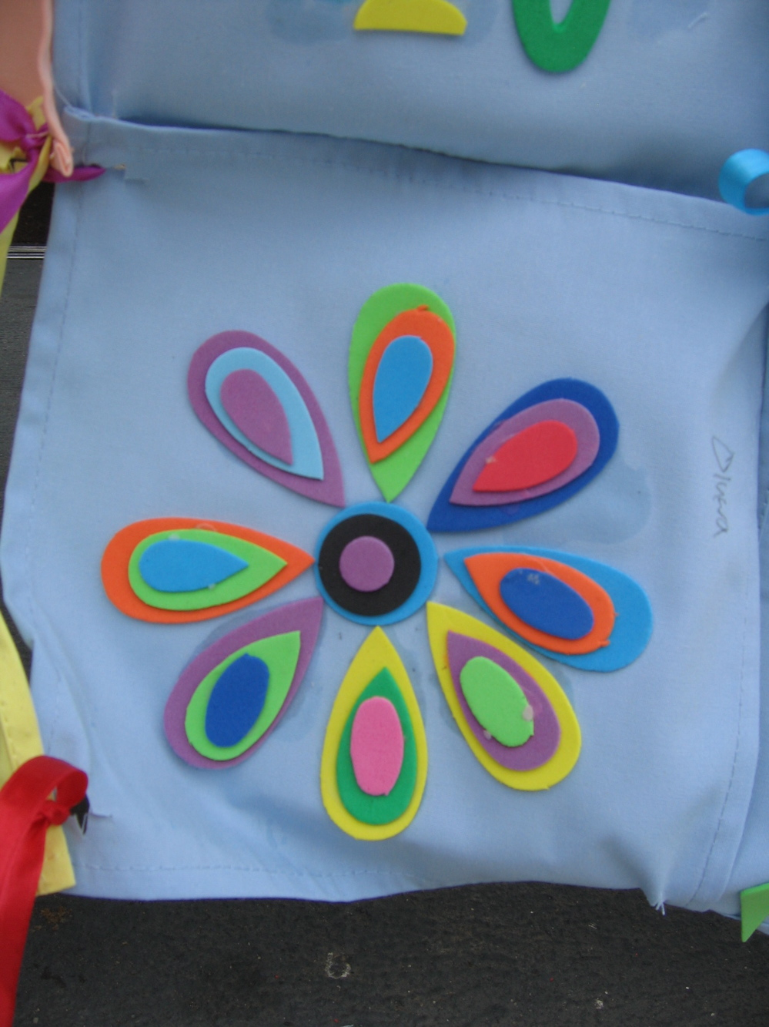
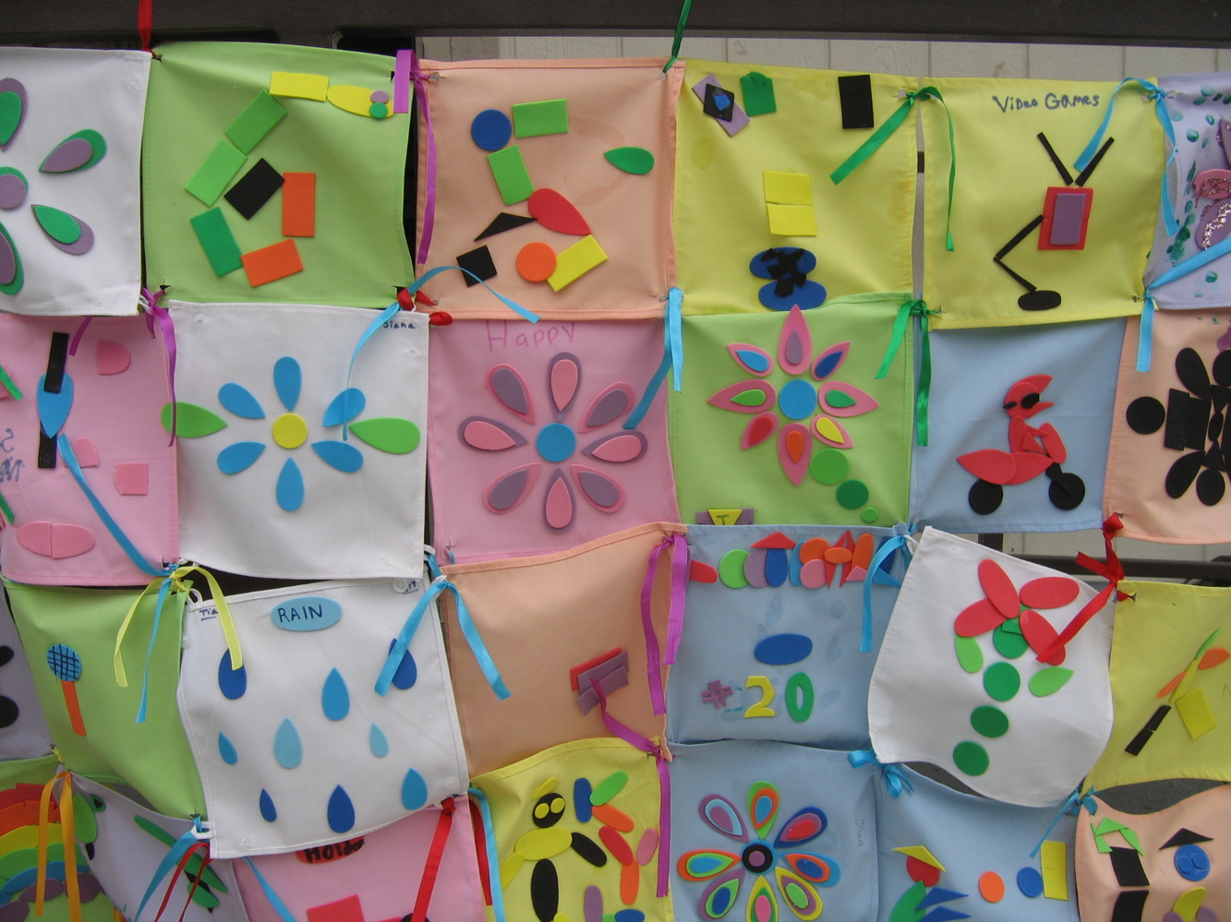

- Choice Activities: Students choose to complete two or more of the following:

- All About Me Posters –
Students complete one of these 17” x 24” posters:
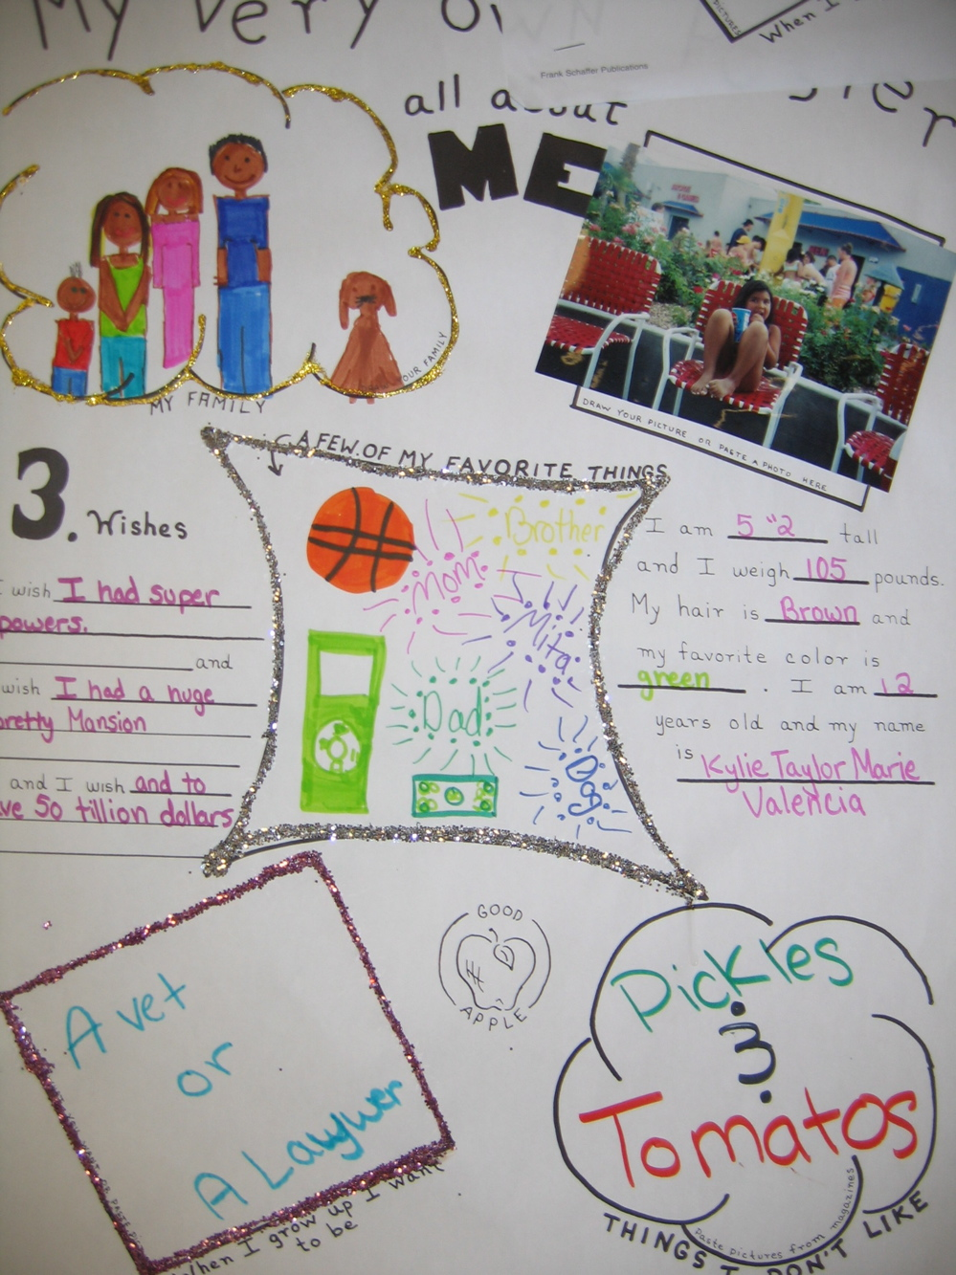
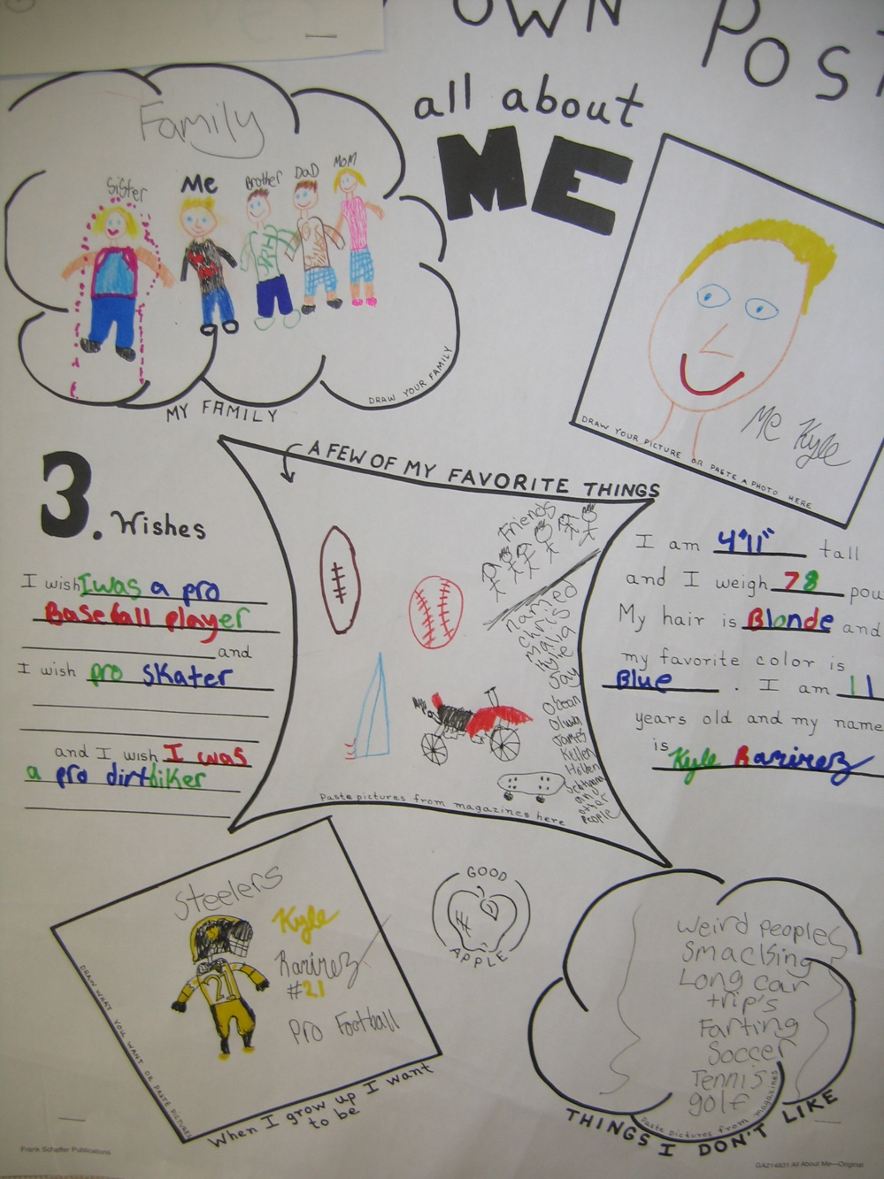

- Through the Years Penny Activity
  - Read The Hundred Penny Box by Sharon Bell Mathis.
  - After reading the book, students find pennies dated each year they have lived.
  - Each student makes his or her own hundred-penny box.
  - The students use the Internet and search for special events that have happened during each of the years they have lived.
http://www.beaconlearningcenter.com/Lessons/121.htm

- Graphic Life Graph – see http://www.readwritethink.org/lessons/lesson_view.asp?id=74
- Name Anagrams -http://www.wordsmith.org/anagram/index.html

Guided Practice and Monitoring

Objective:
- Students write short autobiographical pieces in order to gain skills and experience with the writing skills required for this genre.

Procedure:
Students complete two of the following assignments:

- One Poem – Acrostic OR BioPoem
  - Examples of Acrostic Poems– http://www.poemsforfree.com/namepo.html
  - Directions for BioPoem - http://library.thinkquest.org/11883/data/biopoem.htm

- Create an A to Z books in which each letter stands for a word or phrase about you.
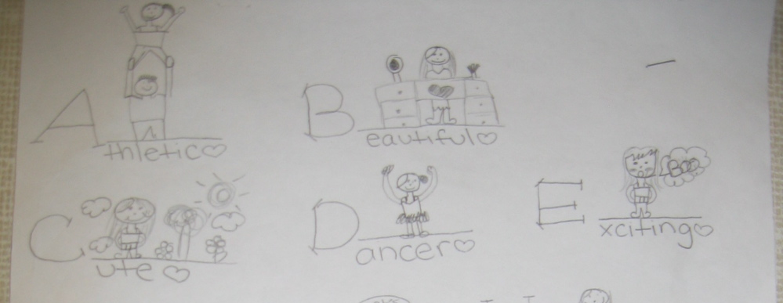
  - Directions for A to Z Autobiography – http://www.education-world.com/a_tsl/archives/05-1/lesson017.shtml

2w
- Complete the Online Tutorial –Write an Autobiography
  - http://www.tv411.org/lessons/cfm/writing.cfm?str=writing&num=13&act=1

Independent Work - Final Project:

Objectives:
- Students will write a five-paragraph autobiography.
- Students will present a multimedia autobiographical presentation.

Procedures:
- Single Incident Paper
- Students write a three paragraph essay about a single incident from their lives.

- Students choose to one of the following as an extension to their single incident paper:
- Song – play an autobiographical song for the students – examples include Dolly Parton’s Coat of Many Colors and/or Neil Young’s Sugar Mountain. Students then use their single incident paper writings to compose a song.

- Poetry – students write a poem using all the adjectives in their incident paper.

- Five Paragraph Essay – Life Autobiography
- Students peer edit the essay using the form found at http://content.scholastic.com/browse/lessonplan.jsp?id=24
- Students are assessed using the Autobiography rubric found at http://content.scholastic.com/browse/lessonplan.jsp?id=24

- Final Project Multimedia PowerPoint Presentation –
- The procedures for this assignment can be found at the following websites
  - http://www.microsoft.com/education/aboutme.mspx
  - http://www.beaconlearningcenter.com/Lessons/1273.htm

To receive full credit, you need to complete the entire assignment (hole punch) + it must be high quality work (second hole punch). If you finish early, you will need to complete another assignment.

Required
  About Me Journal - Required
  BioBags
  Personal Information – At Least Five
- First day of kindergarten;
- first time on a bicycle (or snowmobile, rollerblades);
- first overnight;
- best personal performance;
- funniest day at school;
- first or best pet;
- best friend and how you met.
- the birth of brothers and sisters
- a time when you got hurt
- a time when you won something
- a special birthday
- something that happened to you during a sport or a game

  One Poem – Acrostic OR BioPoem
  An Illustrated Book of Your Life
(to read to Kindergarten Kids)
General Facts or an Additional Challenge - create an A to Z books in which each letter stands for a word or phrase about you.

Choose One of the Following
  Life Graph -
   Online Tutorial –Write an Autobiography
http://www.tv411.org/lessons/cfm/writing.cfm?str=writing&num=13&act=1
  Name Anagrams -http://www.wordsmith.org/anagram/index.html

